|  |  |
| --- | --- |
| www.jmscr.igmpublication.org Impact Factor 5.84  Index Copernicus Value: 83.27  ISSN (e)-2347-176x ISSN (p) 2455-0450  Description: Description: http://jmscr.igmpublication.org/home/images/citation_linking_graphic_12x54_trans.png **DOI:** https://dx.doi.org/10.18535/jmscr/v5i2.74   |  | | --- | |  |   Description: Description: jmscrh.png |

**A Study on C Reactive Protein - Morbidity Predictor in Ischaemic Stroke**

Authors

**Brinda.J1, John Christopher Ponnaiyan2, Suresh Kumar3, Manivel Ganesan4**

1Assistant Professor, Dept of General Medicine, Kanyakumari Government Medical College, Kanyakumari

2Associate Professor, Dept of General Medicine, Kanyakumari Government Medical College, Kanyakumari

3Post Graduate, Dept of General Medicine, Kanyakumari Government Medical College, Kanyakumari

4Intern, Dept of General Medicine, Kanyakumari Government Medical College, Kanyakumari

Corresponding Author

**P. Suresh Kumar**

Post Graduate, Department of General Medicine,

Kanyakumari Government Medical College, Kanyakumari

|  |
| --- |
| **Abstract**  **Background:** *With an annual incidence of 0.2 to 2.5 per 1000 population, CVA is an important health problem worldwide. Though ischaemic CVA is one of the leading causes for death and disability, parameters for predicting, long term outcome in such patients have not been clearly delineated, especially in the Indian context. Various studies proved that C-reactive protein at admission was found to be a predictor of functional disability in ischaemic CVA. Inflammation regulates the production of the acute phase proteins such as c-reactive protein (CRP), fibrinogen and serum amyloid A. The serum concentration of CRP can increase >1000 fold upon inflammation and with a half life of 19 hrs, CRP is a very stable marker of the inflammatory process. Most recent studies report that CRP is an independent predictor of risk of atherosclerosis, cardiovascular events, atherothrombosis, hypertension and myocardial infarction.*  **Materials and Methods:** *The present study is a prospective study and was conducted on 49 patients in the Department of General Medicine, Kanyakumari Government Medical college from January 2016 to January 2016. Various cerebrovascular accident cases admitted in our hospitals were clinically evaluated and diagnosis were confirmed radiologically. All cases were subjected to routine blood investigations along with acute phase proteins (c-reactive protein) on the day of admission and after 4 weeks. In all 49 cases, informed consent obtained from their guardians.*  **Results:** *Out of total 49 cases studied, 18 Cases were females & 31 cases were males. All the cases were grouped into 3 categories by Barthels Index accordingly. Patients with high C- reactive protein levels on the day of admission had more severe deficits and poor prognosis after 4 weeks than compared with other patients with normal level on the day of admission and better prognosis.* |

**INTRODUCTION**

Of several inflammatory markers studies, CRP emerged as the most powerful inflammatory predictor of future cardiovascular and cerebro vascular risk. Also patient with elevated CRP levels within 72hrs of stroke have an increased risk of mortality. CRP in ischaemic stroke predicts outcome and identifies patients who are at risk for future vascular events and early mortality8. CRP has also been found to be elevated in patients with ischaemic stroke, correlating with the size of the infarct as evidenced by CT scan.

Atherosclerosis is a multi factorial disease, driven by inflammatory reactions10. The process of inflammation also contributes to the pathogenesis of acute thrombotic events. CRP is an acute phase protein and its concentration in serum reflects the inflammatory condition by the patient. Levels of CRP are consistently associated with cardiovas-cular disease and predict myocardial infarctions and stroke. Thus, CRP is useful and a reliable predictor of cerebro vascular events.

**MATERIALS AND METHODS**

The study of CRP in ischaemic stroke was carried out in the Department of General Medicine, Kanyakumari Government Medical College. This is an Observational prospective hospital based type of study. The study period was from Jan 2016 to Jan 2017

**INCLUSIONAL CRITERIA**

1. Stroke as defined by WHO, is a rapidly developing clinical signs of focal (at times global) disturbances of cerebral function lasting more than 24 hours or leading to death, with no apparent cause other than that of vascular origin.
2. All patients with CT proven case of ischaemic stroke.
3. First episodes of ischaemic stroke.
4. Do not satisfy any of exclusion criteria.

**EXCLUSION** CRITERIA

1. Age >75 or <15 years.
2. Patients with TIA.
3. Patient with previous H/o stroke, TIA.
4. Patients with haemorrhagic stroke, tumour, sub arachnoid haemorrhage.
5. Patients with head injury within 3 months.
6. CT Negative stroke.
7. Patient who reserved aspirin treatment outside
8. Patient with H/o hypertension, diabetis, heart disease, collagen disorders, hyperli-pidemia, T.B, arteritis were excluded.
9. Smokers were excluded
10. Patients with obesity (BMI >30 kg/M2)
11. Patients with major renal, hepatic, cancerous disease.
12. Patients with meningitis, brain abscess, or any chronic infection that affected CRP value.
13. Those with signs and symptoms of potential clinical infection during the last 4 weeks before stroke.
14. Those with signs and clinical evidence of acquired in hospital infection.

After obtaining verbal consent from either patient or relatives, all patients in the study group were evaluated by complete medical history, full neurological examination, standardized blood tests and imaging studies. Clinical history was recorded from either the patient or his/her relatives. Special emphasis was given to presenting complaint, mode of onset, presence or absence of seizures, loss of conciousness. headache, vomiting etc. Presence or absence of risk factor, for stroke was also noted. Past history of TIA, hypertension, diabetis, coronary arterial disease, rheumatic heart disease collagen disease, tuberculous etc were carefully sought. Personal history regarding dietary habits, smoking, alcoholic status were noted.

Apart from routine observations, markers of atherosclerosis like carotid arteries, status of peripheral vessels, carotid thrill and B.P were noted

A detailed clinical profile was obtained Neurological deficits such as aphasia, cranial Nerve palsies, limb weakness, sensory impair-ment, •cerebellar dysfunction, conjugate gaze deviation and hemianopia were elicited by a standard comprehensive bedside neurological examination. Functional score was assessed using Barthel index. CRP was measured by Nephelom-etric method. Patients were reassessed on the 5th day and condition reviewed. Proper nuring care and physiotherapy were explained to the relatives, caregivers and whenever possible to the patients.

Third evaluation was at 4th week of follow up.

Improvement was objectively assessed by determining the functional status using Barthel index. Doubts and apprehensions of the relatives, caregivers and patients were addressed and cleared. Importance of nursing care and physiotherapy were re-emphasized and absence of confidence and hope were instilled. According to the Barthel index4, patients were divided into 3 groups.

Barthel index <41 severely disabled.

Barthel index 41-60 moderately disabled.

Barthel index >60 mildly disabled.

Detailed analysis of date was performed. Univariate analysis was done by chi.square test and multivariate analysis by logistic regression.

**BARTHEL INDEX OF ACTIVITY OF DAILY LIVING**

**1 Feeding** 0 = Independent .

5 = Needs help (i.e) forcutting .

0 = Inferior performance

**2. Bathing** 5 = Performs without assistance

0 = Inferior performance

5 = Washes face, combs hair, brushes teeth

**3 Personal toilet** 0 = Inferior performance

0 = Inferior performance

10 =Independent

5 = Needs help

**4. Dressing** 0 = Inferior performance

10 = No accidents

5 = Occasional accidents

**5 Bowel control**  0 = Inferior performance

10 = No accidents

5 = Occasional accidents

6 **Bladder control** 0 = Inferior performance

10 = Independent with toilet or bed pan

5 = Needs help for balance

7. **Toilet transfer** 0 = Inferior performance

15 = Independent.

10 = Minimum assistance

5 = Able to sit, Needs assistance to transfer

**8. Chair/ bed transfers** 0 = Inferior performance

15 = Independent for 50 yards

10 = With help for 50yards

5 = Independent with wheelchair for 50 yards, only if unable to walk

9. **Ambulation** 0 = Inferior performance

10 = Independent

5 = Needs help or supervision

**10. Stair climbing** 0 = Inferior performance

Maximum disability: = 0

Minimum disability: = 100

OBSERVATION AND RESULTS

49 patients satisfied all the above criteria were included .31 were Males & 19 were Females. One patient died.

The following observations were made out of the 49 patients,

21 patients had an abnormal increased CRP and 28 patient had normal level.

1. Among patient with positive CRP 13 were male and eight were female CRP level status positive in 21 patients (ie) 42.85%

CRP level positive in males 26.5%

Percentage positive female is 16.32%

For the above date we used chi-square test for the independence of association. The hypothesis shows no association between the 2 groups. So, sex does not influence the CRP of the patient since ch.sq test X2 = .0292 P value >.05.

1. There is no association between age of patient and CRP Ch.sq test X2 = .109

P value >.05

So age factor does not influence the group pattern (CRP +ve)

1. Severe disability is more in CRP +ve positive compared to CRP negative group. Barthel index <41 in severely disabled group.
2. All patients who had aphasia at the time of admission were CRP positive and belonged to the severely disabled group.
3. All patients who had conjugate gaze deviation were CRP positive and belonged to the severely disabled group.
4. All patients with power less than Medical Research Connect (MRC) grade 4 were CRP positive.

Follow up was done at the end of 4 weeks and the following observation made during follow up. Barthel index at day 1 was found to correlate with that at 4 weeks.

1. During follow up, 68% of the CRP +ve belonged to the severely disabled group, 23% of CRP +ve belonged to moderately disabled group.

Among the mildly disabled group, none were CRP +ve.

**Sex Wise Distribution of CRP Level**

|  |  |  |  |
| --- | --- | --- | --- |
| SEX | CRP –ve | CRP +ve | TOTAL |
| Male | 18 | 13 | 31 |
| Female | 10 | 8 | 18 |
|  | 28 | 21 | 49 |

AGE WISE DISTRIBUTION OF CRP LEVEL

|  |  |  |  |
| --- | --- | --- | --- |
| AGE | CRP-ve | CRP +ve | Total |
| >60 | 12 | 10 | 22 |
| <60 | '16 | 11 | 27 |
|  | 28 | 21 | 49 |

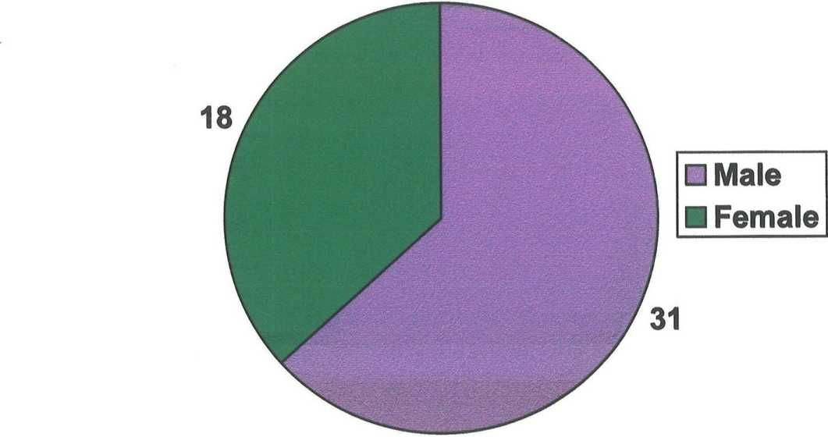CRP Level - Sex wise Distribution

|  |  |  |  |
| --- | --- | --- | --- |
| BARTHEL INDEX | CRP -ve | CRP+ve | TOTAL |
| <41 severely disabled | 7 | 15 | 22 |
| 41-60 moderately disabled | 17 | 6 | 23 |
| >60 mildly disabled | 4 | 0 | 4 |
|  | 28 | 21 | 49 |

CRP LEVEL

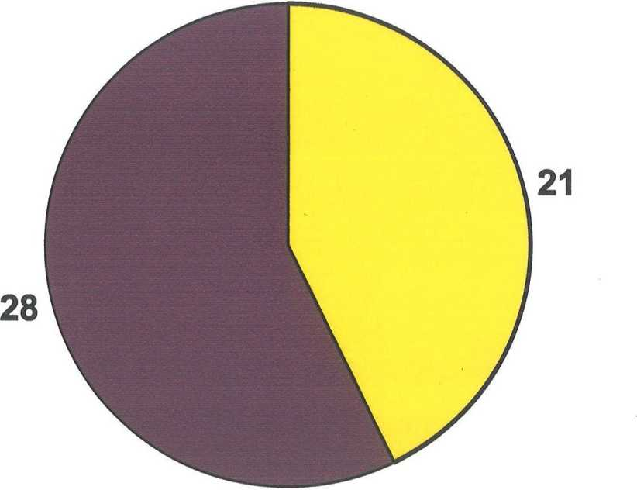

**CRP Increased BCRP Normal**

**CRP AND APHASIA**

|  |  |  |
| --- | --- | --- |
| Barthel index | CRP +ve | Aphasia |
| <41 | 15 | 15 |
| 41-60 | 6 | 3 |

**CRP AND CONJUGATE GAZE DEVIATION**

|  |  |  |
| --- | --- | --- |
| BARTHEL INDEX | CRP +ve | CONJUGATE GAZE DEVIATION |
| <41 | 15 | 15 |
| 41-60 | 6 | 4 |

OUTCOME SCORE AND CRP

|  |  |  |  |  |
| --- | --- | --- | --- | --- |
|  | BARTHEL  INDEX | CRP+ve | CRP-ve | TOTAL |
| Severely disabled | <41 | 15 | 7 | 22 |
| Moderately disabled | 41-60 | 6 | 17 | 23 |
| Mildly disabled | >60 | 0 | 4 | 4 |

**OUTCOME AFTER 4 WEEKS**

|  |  |  |
| --- | --- | --- |
|  | CRP +ve | BARTHEL INDEX |
| Severely disabled | 15 | <41 |
| Mild / moderately disabled | 6 | 41-60 |

**OUTCOME AND CRP %**

|  |  |  |  |  |
| --- | --- | --- | --- | --- |
| BARTHEL INDEX | CRP –ve | % | CRP+ve | % |
| <41 severely disabled | 7 | 31% | 15 | 68% |
| 41-60 moderately disabled | 17 | 78% | 6 | 23% |
| >60 mildly disabled | 4 | 100% | 0 | 0% |

**CRP and Out Come**

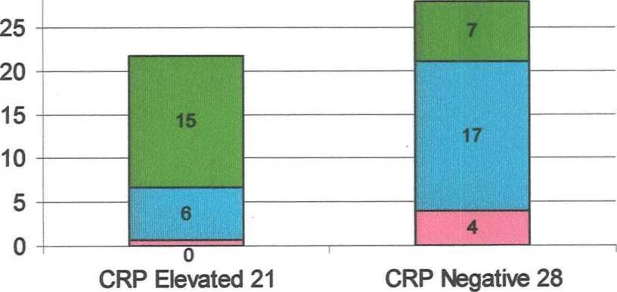

■ Severe (green)

**30**

Moderate(blue)

Mild (pink)

**DISCUSSION**

Stroke or CVA is a rapidly developing clinical symptoms and signs of focal and at times global (applied to patients in deep coma and in those with Sub Arachnoid Haemorrhage) loss of cerebral funtion, with symptoms lasting for more than 48hrs and leading to death with no apparent cause, other than that of vascular origin.

Cerebral infarction accounts for apparently 80% of stroke as opposed to 10% due to primary intra cerebral bleed, 5% due to sub arachnoid haemorrhage and 5% of uncertain etiology.

|  |  |
| --- | --- |
| PATHOLOGICAL TYPE | % |
| CEREBRAL INFARCTION |  |
| 1. Large vessel occlusion 2. Small large vessel occlusion (lacunar infarct) 3. Cardiac emboli 4. Haemotological disorder vasculities 5. Vasculopathy | 80 % |
| PRIMARY INTRACEREBRAL HAEMORRHAGE |  |
| 1. Hypertensive bleeds 2. Vascular malformation 3. Bleeding diathesis anticoagulation | 10% |
| 1. Non traumatic SAH 2. Aneurysm Vascular malformation 3. Non aneuiysm al SAH | 5% |
| Other causes | 5% |

**CAUSES OF CEREBRAL ISCHAEMIC AND INFARCTION**

|  |  |  |
| --- | --- | --- |
| 1. | Arterial wall disorders | Athero thrombolic embolism intra - cranial small vessel disease  (lipohyalinosis, micro atheroma) trauma,  • '  dissection, fibro muscular dysplagia, congenital altered wall anomalies, moyo- moyo disease, embolism, inflammatory, biswangers, irradiations, infections. |
| 2. | Embolism from heart |  |
| 3. | Haematological |  |
| 4. | Miscellaneous | Pregnancy, periperium, OCP, drug - abuse, cancer, IBD,homo cystinemia, Hypoglycemia. Mitochondrial cytopathy, epidermal nerves, snake bite, fat embolism, nephrotic syndrome. |

**RELATIVE IMPORTANT CAUSES OF ISCHAEMIC** **STROKE**

Athero thrombo embolism of cerebral arternal supply 50%

Lipohyalinosis / micro atheroma 25%

Embolism from heart 20%

Miscellaneous 5%

From above tables the following points are evident

1) Cerebral infarction occounts for 80% of all stokes.

2) Athero thrombo embolism of cerebral arterial supply is the cause of 50% of causes of cerebral infarction.

**RISK FACTORS FOR ISCHAEMIC STROKE**

S, Non modifiable risk factors

Age

Sex

Race

Family history

II. Modifiable risk factors

Blood pressure

Diabetes mellitus

Hyper cholesterolemia

Smoking

Cardiovascular diseases

TIA

Carotid artery disease

Drugs

Obesity

Diet

Exercise

**III Other risk factors**

1. **Infection / inflammation.**

Both acute and chronic inflammation play a role in development and stability of atheromatous plaques. There is now evidence of association between stroke and serum CRP.

1. **Haemostalic variables:**

Homocystinemia.

**PATHOPHYSIOLOGY OF ISCHAEMIC STROKE**

There are two pathophysiological process

1. A loss of supply of O2 and glucose secondary to vascular extension.
2. An array of changes in cellular metabolism consequent to the collapse of energy producing processess with disintegration of cell membrane.

**FOCAL CEREBRAL ISCHAEMIA**

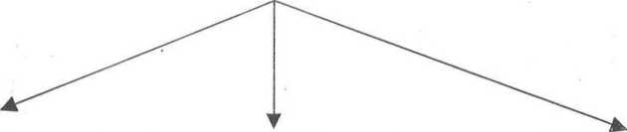

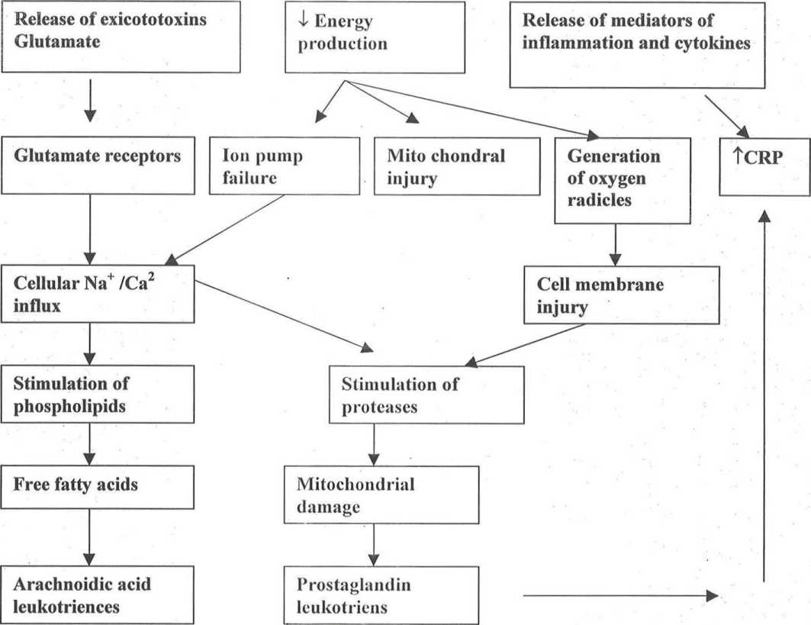

**PREDICTORS OF STROKE OUTCOME**

Although there are promising therapies for acute ischaemic stroke with high expectation of rapid recovery and good outcome, poor outcome can still occur.

This is because, ischaemic stroke is a heterogenous condition, whose outcome is influenced by many factors1,2,3. The extent of brain injury and the result of outcome from ischaemia are largely dictated at a physiological level by the severity and duration of the insult. Demographic variables, risk factors, clinical examination findings, lab test result and imaging studies provide important insight regarding outcome.

**DEMOGRAPHIC FACTORS**

1. **Age**

One of the major factors that negatively influence the outcome for patients with ischaemic stroke. Older patients are less likely to recover than younger patient with similar size infarcts. Poor outcome can be explained by high frequency of secondary complications among elderly stroke patients, having high incidence of other systemic diseases that preclude recovery.

Body temperature predicts and influences stroke outcome for each 1° Celsius increase in body temperature, the relative risk of poor outcome rose two fold. One explanation for this is and increased concentration of excitotoxic neurotransmitter.

While demographic and clinical findings have an established ray in the predictors and prognostic indicator, lab findings have also been found to play an important role.

(1). High serum and CSF glutamate are common in patients with progressive stroke. High level of glutamate or glycine, both of which are excitotoxic neuro transmitters have strongly been related to large infarct size and severe neurological deficit.

2. CNS - specific proteins have been evaluated in blood, at the acute phase of ischaemic stroke such as Sioo and neuron specific enolase.

3. (2). Prognostic value of acute phase reactant such as ESR and CRP

Two inflammatory markers also provide prognostic information.

1. . ESR erythrocyte sedimentation rate
2. . CRP

Some studies have shown male sex associated with poorer outcome, while some other studies have shown no difference. Probably hormonal protection could be the reason as experiments on amimals showed improving stroke.

5. Cerebro vascular risk factors:

Previous stroke and AF. These are 2 major risk factors. Previous H/o stroke has been consistently associated with higher likelihood of death or dependence probably due to lower pre stroke level of function and more advanced cardio - vascular disease. Stroke in patients with atrial fibrillation are usually more severe, more disability and associated with high mortality.

6). Clinical findings :

Level of consiousness and gaze deviation Initial level of consiousness is an important predictor with decreased level of consiousness predicting poor outcome. Presence of gaze deviation is generally associated with poorer outcome. ’

Abnormal B.P may influence outcome. Clinical studies of B.P reduction have shown a decrease in cerebral blood flow to infarction area. On the other hand, highly elevated BP has adverse long term effects in blood - Brain barrier. Hypertension has been found to play a role in haemorrhagic transformation.

ESR: Erythrocyte sedimentation rate independently predicted short term outcome with increased level predicting poor outcome.

CRP: An acute phase reactant has been found to predict outcome. CRP concentrations measured in 72hrs of stroke, independently predicted survival after ischaemic stroke.

Inflammation plays an important role in the initiation and progression of atherosclerosis and systemic blood markers of inflammation (i.e) acute phase reactants such as CRP and fibrinogen have emerged as powerful predictors of coronary and cerebrovascular events1.

The present study is a longitudinal hospital based study focusing on the prognostic factors following ischaemic CVA and includes follow up at 4 weeks. Haemorrhagic stroke was not included to maintain homogeneity in the sample population. Patients with clinical evidence of systemic infection or inflammation were dropped to exclude the other causes for elevated CRP. The inclusion and exclusion criteria as well as dilution of follow up were chosen based on similar studies done from other centers in the world. Follow up was achieved after 4 weeks.

III. CRP:

CRP is one of the substances, present in the atherosclerotic lesion, more specifically in the vascular intima, where it co-localizes with monocytes, monocyte derived macroplaques and lipoproteins. This localization makes a direct contribution to the atherosclerotic process possible15.

CRP is a phylogenitically, highly conserved plasma protein with homologues in vertebrates and many invertebrates, that is part of the systemic response to inflmmation5.

It is an acute phase protein and a member of the family of pentraxins, CRP was originally observed to 1930 in the plasma of patients with acute infections, where it reacts with the C.polysaccharide of pneumococcus5.

The major part of the CRP present in the plasma comes from liver, where the synthesis of CRP is mainly regulated by IL- 6, which in turn is unregulated by other inflammatory cytokines such as IL-1 and TNFa. Small amounts of CRP can also be produced locally. CRP has been detected on the surface of about 4% of normal blood lymphocytes and CRP can be produced locally in the atherosclerotic lesions by smooth muscle cells and monocytic cells14.

The structure of CRP is important for its stability and for the execution of its function. CRP is composed of five identical 21,500 Da subunits. Upon dissociation of its pentameric structure, CRP subunits undergo a spontaneous and irreversible confirmational change. The loss of the pentameric structure of CRP results in modified or monomeric CRP (MCRP) which is a naturally occurring form of CRP and is tissue based rather than serum based molecule.

MCRP is less soluble than CRP and tends to aggregate and it has been described to induce MRNA of chemokines and expression of adhesion molecules in human cultured coronary artery endothelial cells (HCAECS). Thus next to circulating native pentameric CRP, MCRP can also promote a pro inflammatory phenotype and exert atherogenic effects in human endothelial cells, although it may be in less potent manner that native CRP.

The assumption that CRP is a casual factor in the development of the atherosclerotic lesion is based on its rapid accessibility to the plaque, localization in the plaque and the results of in vitro studies in which CRP has been demonstrated to actively contribute to inflammatory process, further more the specific interaction of CRP with complement factors, cell receptors, lipids and other inflammatory mediators occurs the possibility of CRP being directly involved atherosclerosis.

**V. EFFECTS OF CRP ON ATHEROSCLEROSIS:**

Inflammatory mechanisms play a central role in all phases of atheroslcerosis from the intial recruitment of circulating leukocytes from the arterial wall to the rupture which results in the clinical manifestation of the disease. CRP may be involved in each of these stages by the following processors.

**(a) COMPLEMENT ACTIVATION;**

Activation of the classical pathway of the complement system is a well known and direct biological function of CRP, Via this action, CRP directly amplifies and facilities innate immunity. CRP & co localizes with C5-C9, the membrane attack complex of complement. Activation of this Membrance attack complex (MAC) is initiated by direct binding of CRP to Clq also present in the atherosclerotic lesion and characterized by elevated level of complement Csa6. Csa itself exerts protect chemotactic and pro inflammatory effects and its plasma level have been associated with increased cardiovascular risk in patients with advanced atherosclerosis.

**(b) INTERACTION WITH CELL SURFACE RECEPTORS:**

The close proximity of CRP, to monocytic cells in the arterial intima attenuates its possibilities for a direct contribution to the progression of atherosclerosis. The observation that CRP is localized between monocytes underlines the possibility of a direct interaction of CRP with these cells and with monocyte - derived macrophages via binding to a specific receptor CRP binds to several receptors on human monocytes to FcRy II a (CD32) with high affinity and FeRyl (CD64) with lower affinity increasing phagocytosis and the release of inflammatory cytokines.

**THROMBOSIS:**

Thrombosis contributes to the progression of the atherosclerotic lesion and to the precipitation of the cardiovascular event. Direct action of CRP which contribute to the indiction of a prothrombotic state may be the enhancement of the procoagulant activity on the reduction of fibrinolysis. CRP has been suggested to induce a prothrombolic state(via) induction of tissue factor expression in human monocytes out only in the presence of and through direction with other blood cells such as T.lymphocytes, B.lymphocytes and V.K.cells.

**CELLULAR MODIFICATION, RECRUIT-MENT AND ACTIVATION**

CRP contributes to an arterial pro inflammatory and proatherosclerotic phenotype by directly upregulating adhesion molecules and chemo .attractant chemokines in endothelial cells, vascular SMCs and monocytic cells. On the endothelial cells surface, expression of adhesion molecules in the CD40- CD4oligand (CD40L or CD 134) interaction. Like CRP the amount of soluble CD40 increases during inflammation and in the atherosclerotic lesion. Therefore CD40L has been suggested to be a marker for inflammation and involved in risk of cardiovascular events as well. CD40L is shed into the vasculature. Elevated levels of this soluble CD40L (SCD40L) identities patients with acute coronary syndromes, at increased risk of recurrent MI and death, CRP upregulates the cell surface expression of CD40 and CD40L.

**NITRIC OXIDE EXPRESSION**

CRP has been described to decrease the expression and bio activity of endothelial nitric oxide synthase (CNOS or NOS3), which results in reduced bioavailability of Nitric monoxide (NO) and a subsequent effect of vaso dilatation. CRP contributes to a proatherogenic and prothrombolic state by decreasing the release of NO and of the vaso dilatation and inhibitor of platelet aggregation (prostacyctin 10 GI2) through directly increasing both superoxide and inducible No synthase such as ICAM-1, VCAM-1 and E.selection is upregulated by CRP, via these processors, CRP induces platelet adhesion to endothelial cells. CRP also appears to be involved in the infiltration of monocytes into the vessel wall and other subsequent development into foam cells, CRP is chemotactic for human blood monocytes.

**EXPRESSION OF INFLAMMATORY MEDIATORS CYTOKINES CHEMOKINES AND ADHESIVE MOLECULE**

CRP induces inflammatory cytokines in a dose dependent way CRP induced release of interleukin-6, interleukin-1, and TNFa all 3 cytokines were detected 4hrs after CRP elevation with maximal level of TNFa at 8hrs and IL-1 and IL-6 at 16hrs. CRP increases IL-8 protein and MRNA expression in a time and dose dependent manner (via) specific up regulation of NF KB activity.

In atherosclerotic lesions, CRP directly upregulates MRNA expression of the macrophage markers CDIIb and HLA DR as well as their protein products.

Another mechanism by which CRP influences the development and maintenance of the atherosclerotic lesion is its direct involvement.

**APOPTOSIS**

CRP is directly involved in the process of apoptosis. It binds to apoptotic cells in a Ca2+ dependent manner and augments the classical pathway of compliment activation, but protects the cells from assembling the terminal complement components (C5-C9)13. Further CRP enhances opsonization and phagocytosis of apoptotic cells. CRP plays an essential role in induced apoptosis of vascular smooth muscles. CRP also binds to phosphatidyl cholines, by which it participates directly in activation of macrophages and neutrophils in the clearance of apoptotic and necrotic cells.

**LIPID**

Interaction between lipids and CRP is divers. It has been suggested that CRP could be the factor that links lipoprotein deposition and complement activation in atherosclerotic plaques. The majority of sub endothelial foam cells show positive staining for CRP. High levels of HDL are atheroprotective since HDL is involved in transporting cholesterol from periphery to the liver, HDL might also protect the endothelium, since CRP induced up regulation of inflammatory adhesion molecules in HUVECS (HUman Vascular Endothelial Cells) was completely blocked by HDL. So HDL neutralizes CRP induced pro.inflammatory activity HDL also inhibits atherosclerosis through prevention of oxidation of LDL.

Thus CRP plays role in complement activation, cell adhesion and recruitment, thrombosis, the expression of regulatory cytokines, apoptosis and lipids. All these mechanism are part of or are compromised by the process of inflammation. CRP may thus contribute to the development of atherosclerotic lesion (Via) direct pro-inflammatory effects.

CRP may be a casual factor as well as a marker for inflammation, depending on the concentration. This concentration of CRP depends on rates of production and clearance. The fact that CRP is avery stable protein which is not consumed to a significant concentration, in any process and the clearance of which is not influenced, by any known condition is in agreement with its functioning as a casual factor attempting to prolong the stability of atherosclerotic lesion.

**FRAMINGHAM STUDY!**

To address the issue of baseline CRP level and risk of subsequent stroke events the measurement of CRP was done in member of Framingham study, Original cohort, who were free of stroke or TIA at the time of 1980 to 1982 clinical examination and related the baseline CRP plasma concentration to the incident of first stroke or TIA in there subjects during 12-14 years follow up. Men had twice the risk of ischaemic stroke and women with highest CRP level had 5 fold increase in the risk of any vascular event and 7 fold increase in the risk of combined outcome of myocardial infarction and stroke. The data derived from the outcome of this study demonstrated a graded increase in the incidence of ischaemic stroke and TIA with increased level of CRP.

CRP levels are known to be greater in smokers. Obese individuals with (BMI >130% of ideal), individuals with abnormal fibrinolytic activity (plasmin - antiplasmin complex) and individuals with subclinical atherosclerosis). All of these afore mentioned are individual risk factor of adverse cerebro vascular or cardiovascular events. But in a trend analysis conducted as a part of this study, showed the relationship between the increased incidence of stroke and TIA with increased level of CRP persisted even after, adjusting for a number of potential confounders including smoking systolic BP, total and HDL cholesterol and diabetics.

Elevated CRP are not disease specific, but are sensitive markers produced in response to tissue injury, infective agents immunologic stimuli and inflammation cytokines such as IL-6, IL-1 and TNF aare highly correlated with CRP and their function5. Inflammation not only appears to be a response to the underlying atherosclerotic disease process, but also be an integral part of it. This is consistent with beneficial effects of anti inflammatory agents such as aspirin in reducing the risk of both cardiovascular or cerebro vascular events. All these date support the view that CRP as a marker of low level inflammation, predicts an increased risk of atherosclerosis.

In the Framingham study, the data were obtained in a elderly cohort of men and women and led to the conclusion that elevated level of CRP significantly predicted greater risk of ischaemic stroke or TIA in elderly men and women7.

**PROGNOSTIC INFLUENCE OF INCRE-ASED CRP AFTER** **FIRST EVER ISCHAEMIC STROKE**

In their study Ridler and colleagues found an association between evidence of inflammation after myocardial infarction and increased risk of recurrent cerebral events.

This encouraged Mario-Di Napoli and Co to conduct a study on the role of CRP level in short term prognosis after first ever ischaemic stroke. About 30 ischaemic stroke patients of either gender (combined) with the age group 49-90 yrs were studied within 4 weeks of the occurrence of the first ever CVA ischaemic event1,2,3. No patients with evidence of acute infection were included in the series CRP was collected with in a medium of 14days from stroke event. It was found that patients with highest CRP level >5mg/dl at study entry died or had severe complication after stroke such as pulmonary embolium or had no evidence of recovery during the 2 months follow up.

This study concluded that CRP was increased in patients with cerebral ischaemia, the higher levels, correlating with significant neurological deficit and relevant disability and appear to provide additional information regarding prognosis after ischaemic stroke11, as it appear to do after myocardial infarction.

**PROGNOSTIC INFLUENCE OF INCREASED CRP AND** **FIBRINOGEN IN ISCHAEMIC STROKED)**

Mario Di Napoli and Co also did a study to investigate and compare the one year prognostic influence of fibrinogen and CRP on the outcome of ischaemic stroke. This led to two conclusions

Increased level of CRP are associated with worse outcome in patients with ischaemic stroke and

Increased risk associated with elevated CRP is independent of the prognostic influence of fibrinogen.

**INFLAMMATION AND STROKE**

All 85 year old inhabitants of Leiden Netherlands were visited at their place of residence (response rate was 87%). Production levels of the anti inflammatory cytokines IL-10 were assessed in a whole blood assay, whereby lipopolyacchande was used as a stimulation. Plasma concentrations of CRP were also used as a marker of inflammation. A history of stroke was obtained at baseline (prevalence 10%). The number of fatal strokes was prospectively obtained for a median follow up of 2.6 years (incidence 1.82 per 100 person yearial rule). Subjects with a history of stroke had significantly lower median IL-10 production levels at baseline than subjects without stroke. They also had higher median CRP concentrations.

Low IL-10 production level and high plasma CRP concentrations are associated with an increased risk of stroke.

**C.REACTIVE PROTEIN AND OUTCOME AFTER FIRST EVER ISCHAEMIC STROKE8**

In study by Dr.Keith W.Muir, Department of Neurology, institute of Neurological sciences, southern general hospital Glasgow. Patients admitted to an acute stroke unit serving a catchment population of 226000 were studied. Survival time and cause of death for up to 4 years after the index stroke were determined and related to CRP concentration within 72 hours of stroke and known prognostic variables by a COX proportional hazards regression model. Ischaemic stroke was diagnosed in 228 of 283 consecutive admissions. Median follow up was 959 days Geometric mean CRP concentration was lO.lmg/L. Survival in those with CRP > lO.lmg/L was significantly worse than with CRP < 10.1. Higher CRP concentration was an independent predictor of mortality together with age and stroke severity on the National Institute of Health strokescale12.

**CRP MORBIDITY PREDICTOR IN ISCHAEMIC STROKE**

A prospective hospital - based study of 105 patients of ischaemic stroke was conducted in Department of Neurology by Dr.H.Npanicker, M-Thomes and Co Focal neurological deficits and functional score was assessed and CRP was measured. A follow up was done at 5 days and at 6 months and outcome variable was the functional status at 6 months using. Barthel index by activities of daily living. Accordingly, patients were grouped into three -p arthel index <41 severely disabled, Barthel index 41-60 moderately disabled, and Barthel index >60 mildly disabled . The results were if at admission if upper limb power was less than MRC grade 4 or aphasia was present or CRP assay was positive, then at 6 months there patients belonged to the severely disabled group. If upper limb of lower limb power was greater than MRC grade 3 or there was no aphasia or conjuate gaze deviation or CRP array was negative, these patients most likely belonged to the mildly disabled group at 6 month. Conclusion was patient can be stratified according to the predicted prognosis9.

**CRP AND INFARCT SIZE**

In patient with ischaemic stroke, the extent of necrosis is the main, though not the only determinant of prognosis studies showed that CRP concentration were increased (>5mg/dL) in patients with larger infarct size and worse outcome. Smaller increase were reported with small infarcts.

The strong association between infection and ted CRP concentration may result from accurate quantification of cerebral infarction by CT and from variable intensity of acute phase response to inflammatory stimuli ( in this case, the extent of cerebral infarction). The possibility was suggested by the observation that 24 hours concentration were much higher in patients with previously raised level.

If the intensity of the acute phase response was not proportional to the intensity of the inflammatory stimulus, the variable increase in CRP concentration may not just be consequence of later recanalisation or persistent occlusion of infarct related artery. Thus the prognostic importance of the 24 hours concentration may be related partly to the extent of necrosis and partly to the unknown individual determination of the intensity of acute phase response. CRP might thus indicate the inflammatory status during the acute phase of ischaemic stroke and might aid in the current challenge proved in secondary prevention11.

Activities of daily living reported after 4 weeks have been shown to correlate highly with those measured from direct examination. This novel method ensured a good follow up.

Significant changes in the disability pattern were not expected during the immediate post stroke period. Hence 4 weeks was chosen as follow up period. By 6 months the long term disability pattern was the same as that of 4 weeks.

CRP is the prototype of the acute phase reactants as it shows earliest and maximum elevation in inflammation. It is secreted by the liver in response to a variety of inflammatory cytokines and level rises following trauma, inflammation and infection. While CRP is a well known prognostic factor following coronary events, association with CVA is not well delineated. C.Reactive protein may be elevated following ischaemic stroke, because of inflammation consequent to cerebral infarction, inflammation, consequent to the unstable athersclerotic plaque and complications secondary to stroke. Latex agglution can also be used for CRP estimation, instead of Nephelometry, because of easy availability, simple, cost effective. Thus prognosis following ischaemic stroke can be determined without much burden on the existing infrastructure of the health care system. Serial measurement of CRP was not within the scope of this study, but may be planned in future studies.

The present study did not include factors that could modify the end point such as compliance to treatment and occurrence of co. morbidities. But this has not been taken into consideration in previous studies such as Muir et al and hence the results are comparable. Upper limb power and aphasia was found to be important prognostic factor.

The findings of this study are significant for several reasons.

C.Reactive protein level at admission was found to be a predictor of functional disability in ischaemic CVA. In the study by Muir et all, a prospective observational study, based in a University Hospital, Acute stroke unit, serving a population of 2,60,000 survival time and cause of death for up to 4 years after the index stroke were determined and related to CRP concentration within 72 hours of stroke and known prognostic variables by COX proportional hazards regression. Ischaemic stroke was diagnosed in 228 of 283 admission. Median follow up was 959 days. Geometric mean CRP concentration was lO.lmg/L. Survival in those with CRP > 10.1 mg/L was significantly more than in those with CRP <10.1 mg/L. Higher CRP was an independent predictor of mortality, together with age and stroke severity on the National Institutes of Health stroke scale. Cardiovascular disease, accounted for 76% of deaths in those with CRP >10.1 mg/L and 63% of death in those with CRP <10.1mg/L. The conclusion was CRP concentration is an independent predictor of survival after ischaemic stroke. Unlike in the previous study by Muir et al, where end point taken was mortality, the present study has studied morbidity (functional status) and hence one step forward. The follow up generated an enthusiastic response. The relatives, caregivers and patients were immensely benefited. Similar study was conducted in Dept of Neurology Sree Chitra Thirunal Institute of Medical sciences by Dr.Jalesh N Panicker, M.Thomas, where Barthel index at day 1 was found to correlate with that of 6 months, correlation coefficient being 63%.

Cerebro vascular accident is an important health problem and is one of the leading cause for morbidity and mortality. The variables found in this study can be used to predict prognosis even at the peripheral hospitals. This helps in stratification of patients depending on the likely outcome and will help the treating physician and the relatives. Though intensive and scientific physiotherapy and rehabilitation can be planned for all patients with ischaemic CVA, the protocol is to be strictly adhered to in patients predicted to have worse prognosis. So that they receive maximum support and assistance. Prognosis can be discussed with caregivers and relatives and the social implication of the illness can be addressed before the patient is sent home. The relationship between CRP and cerebro vascular disease has a bearing on newer treatment modalities of the future. As a subset of patients with stroke has elevated CRP, the role of anti inflammatory agents and antibiotics in the acute management of such patients is to be addressed. As elevated CRP is an index of increased risk for cardio vascular disease, these patients can be targeted with more aggressive, conventional therapy, or new therapies for plaque stabilisations. Many trials are in progress, and are needed to determine, if patients should be treated on the basis of elevated CRP alone.

**CONCLUSION**

CRP is increased in a significant fraction of ischaemic stroke. Increase in CRP is independent of age & sex. Patient with increased CRP had invariably more deficit during admission. Patients with low CRP had mild deficit during admission. Patients with low CRP had good prognostic outcome 4 weeks after onset of stroke. Patient with increased CRP had severe disability when compared with patients with normal levels, 4 weeks after the onset of stroke.

**REFERENCE**

1. Di Napoli M, Di Giantilippa a, sollecito A Bocala V - CRP and outcome after first ever stroke 31(1) 238 - 9 Jan 2001
2. Di Napoli M, Di Gianfillippo G, Bocala V C.Reactive protein after first ever ischaemic stroke Neurology 1999, 52 : A 151 - A 152
3. Muir K.N., Weir CJ Alwan W, squire IB, Lees KR, C.Reactive protein and outcome after ischaemic stroke : Stroke 1999 ; 30 : 981 -985
4. Mahoney FI, Barthel DW, functional evaluation, the Barthel Index Md state Med J 1965 : 14 : 61 - 65
5. Grace A.J. Infection, Inflammation and cerebro vascular Ischaemic Neurology 1997 : 49 (suppl 4): S 47 - S 51
6. Volanakis JE complement activation by C.Reactive protein complexes.
7. Plasma concentration of C.Reactive protein and risk of Ischaemic stroke and Transient Ischaemic attach. The Framingham study Natalia S.Rost, Philip A Wolf, Carlas S.kase stroke 2001 : 32 : 2575 - 2579.
8. Morbidity predictors in ischemic stroke J N Panicker, M.Thomas, K.Parithran D.Nair, P.S.Sarma Neurology India Vol 51 No 1 Jan - mar 2003 pp 49 -51
9. Wide Range C Reactive Protein efficacy in acute ischaemic stroke patients S.Shenhar - Tsartaty, E.Ben Assayag, I.Bova. Acta Neurol Scand 2006 : 114 : 29 - 32.
10. CHAMORRO A. Role of inflammation in stroke and athero thrombosis.Cerebro vascular diseases 2004 : 17 (Suppl 3) 1-5
11. Winbeck K, Poppert H, Etgen T, Cornard B, Sander B, Prognostic relevance of early serial C Reactive protein measurement after first ischaemic stroke 2002 ; 33 ; 2459-64.
12. CRP in cerebro vascular events, Carnova CR, Courtin C Rein hart W.H. Atherosc-lerosis 1999 Nov 1 : 147(1) : 49 -53.
13. Complement C3 and C.Reactive protein are elevated in South Asians Independent of a family History of stroke. Somane R, Grant PJ, Kain K stroke 2006 Jun 29.
14. Zwaka T, Homback V, Torzewski J C.Reactive protein mediated low density lipo protein up take by macrophages. Implications for atherosclerosis circulation 2001 : 103 : 1194- 1197.
15. C Reactive Protein, carotid intima media thickness and incidence of ischaemic stroke in the elderly the cardiovascular Healthy study circulation 2003 Jul 15: 108(2) 166-70.